SEM-1 GROWTH AND DEVELOPMENT

What is definition of growth and development?
What is definition of growth and development?

Growth refers to the increase in mass and size of a body or organs. It typically occurs through the multiplication of cells and an increase in intracellular substance. Development refers to the physiological and functional maturation of the organism. (বৃদ্ধি বলতে একটি দেহ বা অঙ্গের ভর এবং আকার বৃদ্ধি বোঝায়। এটি সাধারণত কোষের সংখ্যাবৃদ্ধি এবং অন্তঃকোষীয় পদার্থের বৃদ্ধির মাধ্যমে ঘটে। বিকাশ বলতে জীবের শারীরবৃত্তীয় এবং কার্যকরী পরিপক্কতা বোঝায়।)

What are the 7 principles of growth and development?

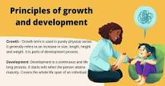

Principles of growth and development
- Principle of continuity: ...
- Principle of Individual differences: ...
- Principle of orderly development: ...
- Uniformity of Pattern: ...
- Principle of interaction and maturation and learning: ...
- Principle of unique development: ...
- Principle of differential development: ...
- Principle of inter-related development:
• ধারাবাহিকতার নীতি:... • স্বতন্ত্র পার্থক্যের নীতি: ... • সুশৃঙ্খল বিকাশের নীতি: ... • প্যাটার্নের অভিন্নতা: ... • মিথস্ক্রিয়া এবং পরিপক্কতা এবং শেখার নীতি: ... • অনন্য বিকাশের নীতি: ... • ডিফারেনশিয়াল ডেভেলপমেন্টের নীতি:... • আন্তঃসম্পর্কিত উন্নয়নের নীতি:

What is growth and examples?
Growth is defined as a gradual development in maturity, age, size, weight or height. An example of growth is a wild teenaged girl becoming much calmer in her late twenties. An example of growth is a boy getting an inch taller between the ages of 14 and 15. (examples?বৃদ্ধিকে পরিপক্বতা, বয়স, আকার, ওজন বা উচ্চতায় ধীরে ধীরে বিকাশ হিসাবে সংজ্ঞায়িত করা হয়। বৃদ্ধির একটি উদাহরণ হল একটি বন্য কিশোরী মেয়ে তার বিশের দশকের শেষের দিকে অনেক শান্ত হয়ে উঠেছে। বৃদ্ধির একটি উদাহরণ হল একটি ছেলে 14 থেকে 15 বছর বয়সের মধ্যে এক ইঞ্চি লম্বা হয়।)

- What are the various stages of growth and development?
- Different stages of growth and development

Stages | Time period
Early childhood | 2 to 6 years.
Late childhood | 6 to 12 years.
5. Adolescence | 12 to 21 years.
Pre adolescence | 12 to 16 years

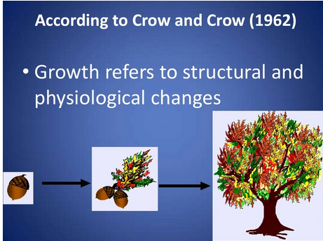


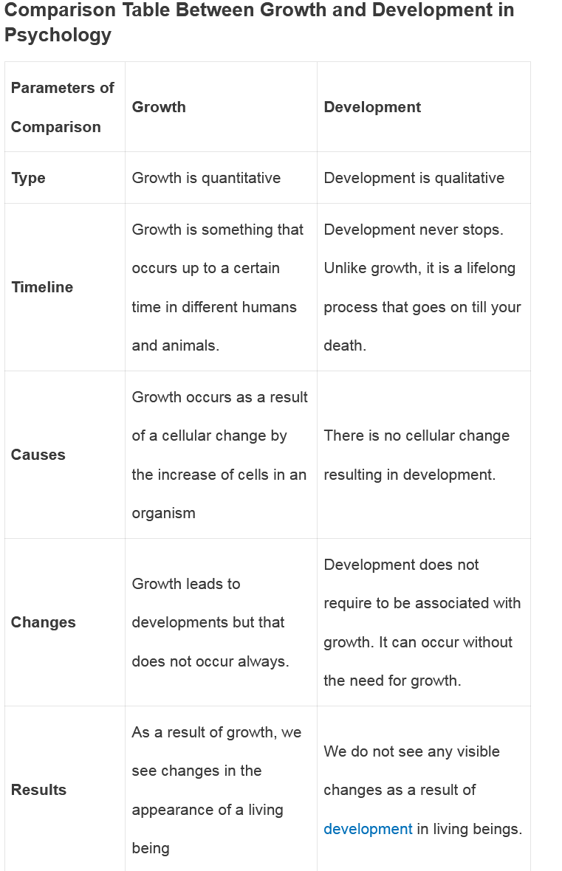
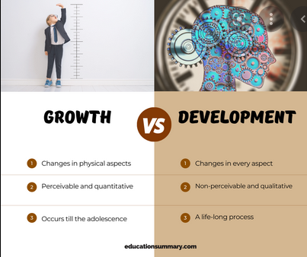
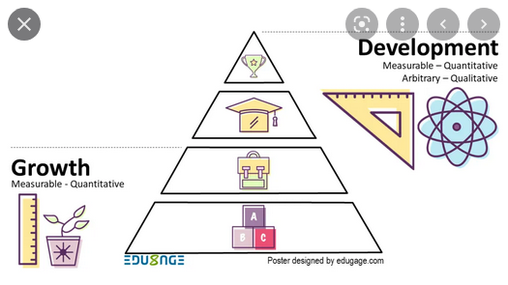

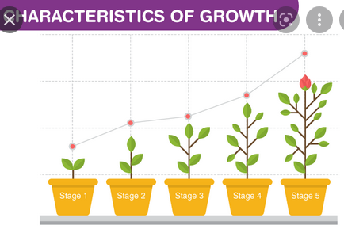
Factors Affecting The Growth And Development Of Children
- Heredity : ...
- Environment : ...
- Gender : ...
- Hormones : ...
- Exercise : ...
- Nutrition

////////////////////////////////////////////////////////////////////////////////////////////////////////////////////////////////
YOGA
What is the simple definition of yoga?

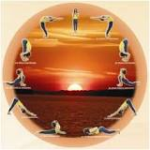

Introduction :Yoga is essentially a spiritual discipline based on an extremely subtle science, which focuses on bringing harmony between mind and body. It is an art and scince of healthy living. The word 'Yoga' is derived from the Sanskrit root 'Yuj', meaning 'to join' or 'to yoke' or 'to unite'
ভূমিকা: যোগ মূলত একটি অত্যন্ত সূক্ষ্ম বিজ্ঞানের উপর ভিত্তি করে একটি আধ্যাত্মিক শৃঙ্খলা, যা মন এবং শরীরের মধ্যে সামঞ্জস্য আনতে ফোকাস করে। এটি একটি শিল্প এবং সুস্থ জীবনযাপনের বিজ্ঞান। 'যোগ' শব্দটি এসেছে সংস্কৃত মূল 'যুজ' থেকে, যার অর্থ 'যোগ দেওয়া' বা 'জোয়াল করা' বা 'একত্রিত হওয়া'।
The 7 True Traditional Types of Yoga
- Raja Yoga. Raja Yoga is Yoga of the mind. ...
- Karma Yoga. Karma Yoga is the Yoga of action. ...
- Jnana Yoga. Jnana Yoga is the Yoga of knowledge and wisdom. ...
- Bhakti Yoga. Bhakti Yoga is the Yoga of devotion and love for the Supreme, God or a Guru. ...
- Mantra Yoga. ...
- Tantra Yoga. ...
- Hatha Yoga
AIMS AND OBJECTIVES OF YOGA EDUCATION
- To enable the student to have good health.
- To practice mental hygiene.
- To possess emotional stability.
- To integrate moral values.
- To attain higher level of consciousness.
• শিক্ষার্থীকে সুস্বাস্থ্যের অধিকারী করতে। • মানসিক স্বাস্থ্যবিধি অনুশীলন করা। • মানসিক স্থিতিশীলতা থাকা। • নৈতিক মূল্যবোধ সংহত করা। • চেতনার উচ্চ স্তর অর্জন করতে।

9 Benefits of Yoga
If you’ve done your “downward dog” yoga pose today, you’re probably feeling more relaxed. Regardless of your level of yoga expertise, if you’re practicing regularly, you can feel better from head to toe.
Yoga offers physical and mental health benefits for people of all ages. And, if you’re going through an illness, recovering from surgery or living with a chronic condition, yoga can become an integral part of your treatment and potentially hasten healing.
A yoga therapist can work with patients and put together individualized plans that work together with their medical and surgical therapies. That way, yoga can support the healing process and help the person experience symptoms with more centeredness and less distress.

1. Yoga improves strength, balance and flexibility.
Try it: Tree Pose
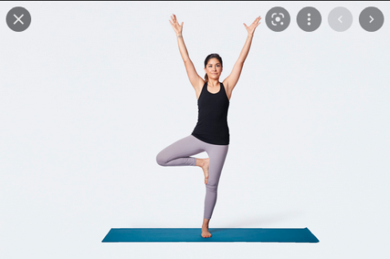

2. Yoga helps with back pain relief.
Try it: Cat-Cow Pose
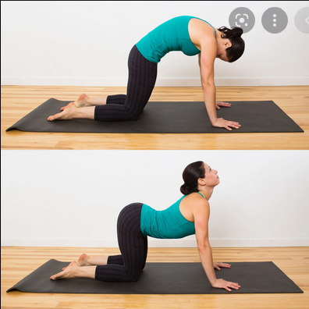

3. Yoga can ease arthritis symptoms.
Gentle yoga has been shown to ease some of the discomfort of tender, swollen joints for people with arthritis, according to a Johns Hopkins review of 11 recent studies.

4. Yoga benefits heart health.
Try it: Downward Dog Pose
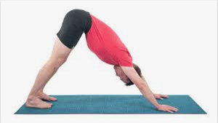

5. Yoga relaxes you, to help you sleep better.

Try It: Legs-Up-the-Wall Pose


6. Yoga can mean more energy and brighter moods.
You may feel increased mental and physical energy, a boost in alertness and enthusiasm, and fewer negative feelings after getting into a routine of practicing yoga.

7. Yoga helps you manage stress.
According to the National Institutes of Health, scientific evidence shows that yoga supports stress management, mental health, mindfulness, healthy eating, weight loss and quality sleep.
Try It: Corpse Pose (Savasana)
You can hold this pose for 5 to 15 minutes.
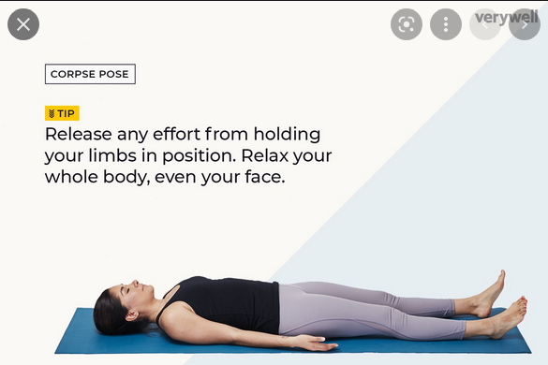

8. Yoga connects you with a supportive community.
Participating in yoga classes can ease loneliness and provide an environment for group healing and support. Even during one-on-one sessions loneliness is reduced as one is acknowledged as a unique individual, being listened to and participating in the creation of a personalized yoga plan.

9. Yoga promotes better self-care.

Scientific Research on Yoga Benefits
The U.S. military, the National Institutes of Health and other large organizations are listening to — and incorporating — scientific validation of yoga’s value in health care.
Numerous studies show yoga’s benefits in arthritis, osteopenia, balance issues, oncology, women’s health, chronic pain and other specialties.
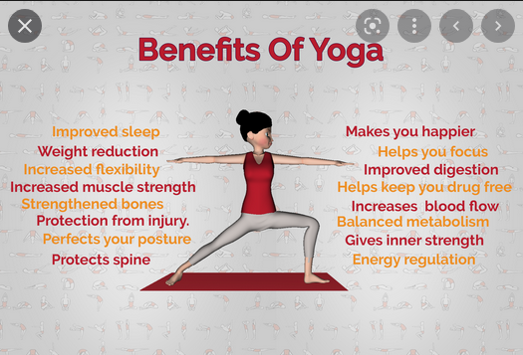
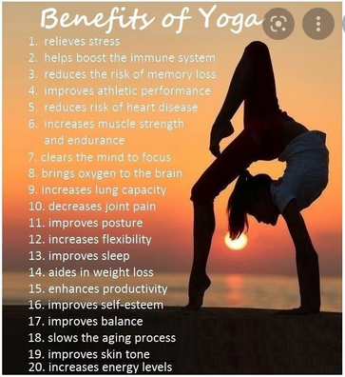
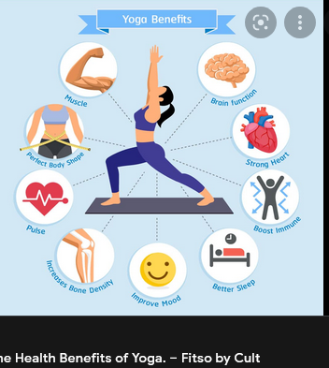
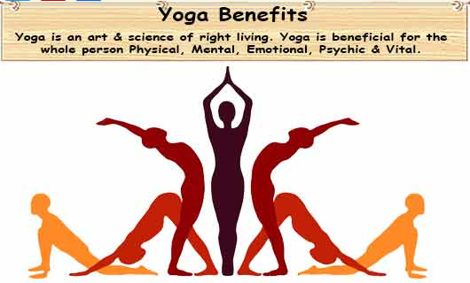
//////////////////////////////////////////////////////////////////////////////////////////////////////////////////////////////
ASTANGA YOGA
What are the 8 stages of Ashtanga Yoga?
In Sanskrit, as they were originally composed, these eight steps are Yama, Niyama, Asana, Pranayama, Pratyahara, Dharana, Dhyana and Samadhi. The eight steps of Ashtanga yoga can be understood under three parts
সংস্কৃতে, যেহেতু এগুলি মূলত রচিত হয়েছিল, এই আটটি ধাপ হল যম, নিয়ম, আসন, প্রাণায়াম, প্রত্যহার, ধরন, ধ্যান এবং সমাধি। অষ্টাঙ্গ যোগের আটটি ধাপ তিনটি অংশে বোঝা যায়.

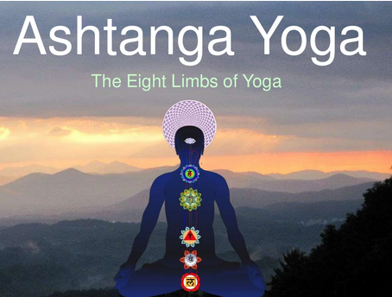
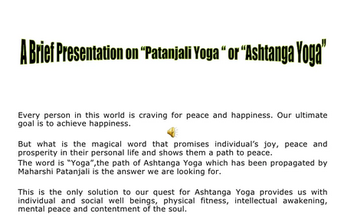
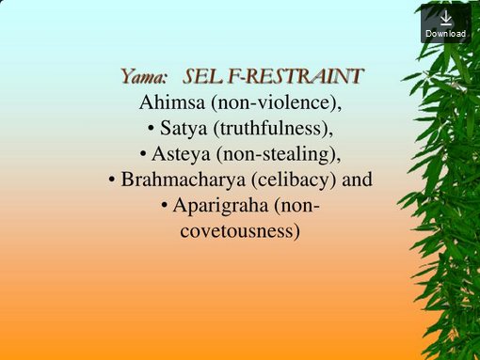
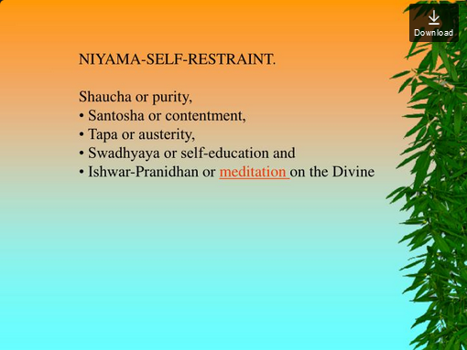
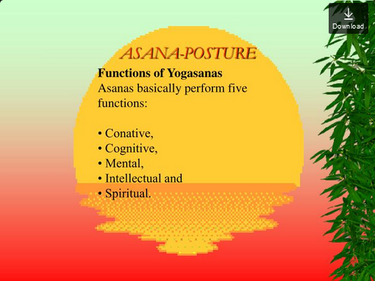
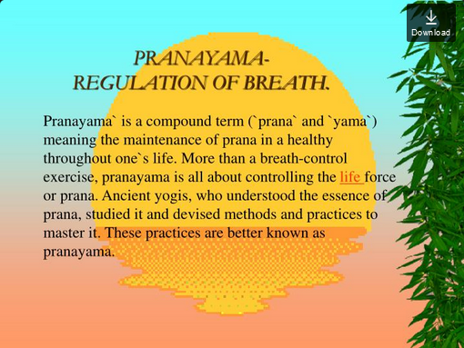

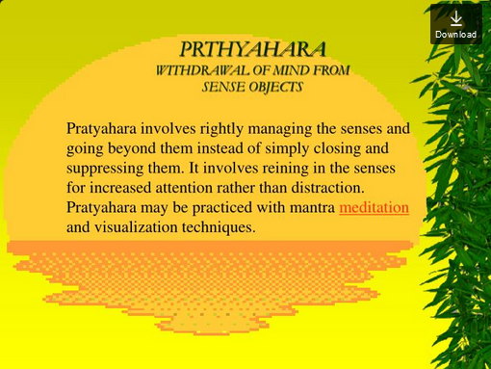
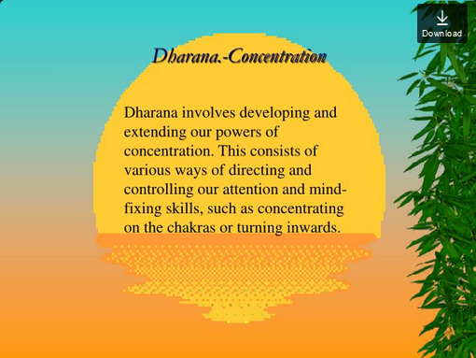
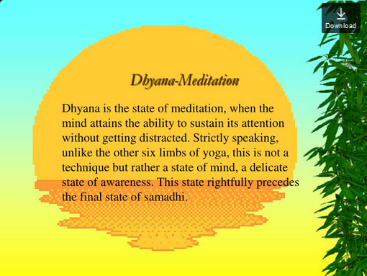
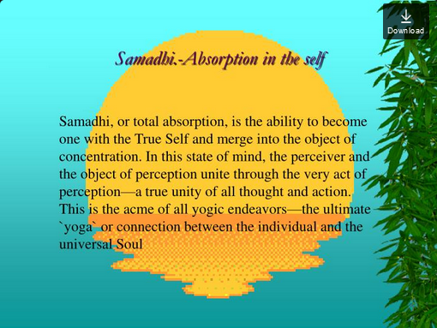
//////////////////////////////////////////////////////////////////////////////
HATHA YOGA

Haṭha yoga is a branch of yoga. The Sanskrit word हठ haṭha literally means "force" and thus alludes to a system of physical techniques.

What is Hatha Yoga good for?
The regular practice of Hatha Yoga enhances strength, flexibility, and balance and may offer some light to moderate aerobic conditioning as well, depending on the style practiced. Other benefits may be gained from incorporating breath work (pranayama) and meditation as part of, or in addition to, a Hatha Yoga practice.

হঠ যোগের নিয়মিত অনুশীলন শক্তি, নমনীয়তা এবং ভারসাম্য বাড়ায় এবং অনুশীলন করা শৈলীর উপর নির্ভর করে কিছুটা হালকা থেকে মাঝারি অ্যারোবিক কন্ডিশনারও দিতে পারে। শ্বাস-প্রশ্বাসের কাজ (প্রানায়াম) এবং মেডিটেশনকে একটি হঠ যোগ অনুশীলনের অংশ হিসেবে বা ছাড়াও অন্তর্ভুক্ত করার মাধ্যমে অন্যান্য সুবিধাগুলি অর্জন করা যেতে পারে।
BENEFITS OF HATHA YOGA
The regular practice of Hatha Yoga enhances strength, flexibility, and balance and may offer some light to moderate aerobic conditioning as well, depending on the style practiced. Other benefits may be gained from incorporating breath work (pranayama) and meditation as part of, or in addition to, a Hatha Yoga practice
Is Hatha Yoga a good workout?
‌If you're looking to become more flexible, hatha yoga can help, especially in the hamstrings and spine. Hatha yoga can also help boost abdominal strength and improve balance in less than a month of regular practice

Hatha Yoga
Most forms of yoga in the West can be classified as Hatha Yoga. Hatha simply refers to the practice of physical yoga postures, meaning your Ashtanga, vinyasa, Iyengar and Power Yoga classes are all Hatha Yoga. The word “hatha” can be translated two ways: as “willful” or “forceful,” or the yoga of activity, and as “sun” (ha) and “moon” (tha), the yoga of balance. Hatha practices are designed to align and calm your body, mind, and spirit in preparation for meditation.

পশ্চিমে যোগব্যায়ামের বেশিরভাগ রূপকে হঠ যোগ হিসাবে শ্রেণীবদ্ধ করা যেতে পারে। হঠ বলতে কেবল শারীরিক যোগ ভঙ্গির অনুশীলন বোঝায়, যার অর্থ আপনার অষ্টাঙ্গ, ভিনিয়াসা, আয়েঙ্গার এবং পাওয়ার যোগ ক্লাসগুলি হঠ যোগ। "হঠা" শব্দটি দুটি উপায়ে অনুবাদ করা যেতে পারে: "ইচ্ছাকৃত" বা "জোরপূর্ণ" বা কার্যকলাপের যোগ, এবং "সূর্য" (হা) এবং "চাঁদ" (থা), ভারসাম্যের যোগ হিসাবে। হাথা অনুশীলনগুলি ধ্যানের প্রস্তুতির জন্য আপনার শরীর, মন এবং আত্মাকে সারিবদ্ধ এবং শান্ত করার জন্য ডিজাইন করা হয়েছে।

Hatha Yoga
Hatha is a general category that includes most yoga styles. It is an old system that includes the practice of asanas (yoga postures) and pranayama (breathing exercises), which help bring peace to the mind and body, preparing the body for deeper spiritual practices such as meditation.
Hatha হল একটি সাধারণ বিভাগ যাতে বেশিরভাগ যোগ শৈলী অন্তর্ভুক্ত থাকে। এটি একটি পুরানো পদ্ধতি যা আসন (যোগের ভঙ্গি) এবং প্রাণায়াম (শ্বাসের ব্যায়াম) অনুশীলন অন্তর্ভুক্ত করে, যা মন এবং শরীরে শান্তি আনতে সাহায্য করে, শরীরকে ধ্যানের মতো গভীর আধ্যাত্মিক অনুশীলনের জন্য প্রস্তুত করে।

Haṭha yoga's components include Shatkarmas (purifications, here Nauli), Asanas (postures, here Mayurasana, Peacock Pose), Mudras (manipulations of vital energy, here Viparita Karani), Pranayama (breath control, here Anuloma Viloma).^{[1]}

হঠ যোগের উপাদানগুলির মধ্যে রয়েছে শতকর্ম (শুদ্ধিকরণ, এখানে নৌলি), আসন (ভঙ্গি, এখানে ময়ূরাসন, ময়ূরের ভঙ্গি), মুদ্রা (প্রাণশক্তির হেরফের, এখানে বিপরিতা করণী), প্রাণায়াম (শ্বাস নিয়ন্ত্রণ, এখানে অনুলোমা বিলোমা)।

The Shatkarmas (Sanskrit: षटकर्म ṣaṭkarma, literally six actions), also known as Shatkriyas, are a set of Hatha yoga purifications of the body, to prepare for the main work of yoga towards moksha (liberation).

Yogapedia explains Shatkarma
There are six shatkarmas, each a different purifying technique:
- Neti: a nasal cleansing process intended to purify the nasal passages and bathe the sinuses. It can be performed in two ways: either using a neti pot to cleanse the passages with saline solution, or using a thread passed through the nostrils and out the mouth. These are called jala neti and sutra neti, respectively.
- Dhauti: a cleansing process for the alimentary canal, including the oesophagus, the mouth, the stomach, intestines and rectum. There are 11 types of dhauti to cleanse different parts of the gut. One popular way is to swallow a length of cloth in order to remove phlegm, bile and impurities from the esophagus and stomach.
- Nauli: a cleansing practice for the abdomen which uses the abdominal muscles to massage and stimulate the digestive organs. The muscles of the abdomen are projected forward then contracted in a wave-like movement that increases “bodily fire.” This practice can take a lot of practice to perform effectively, as it requires a lot of abdominal control.
- Basti: a method for purifying the large intestine either with or without water. In the method with water, jala basti, the yogi sits in a tub of water and draws up water into the rectum by practicing uddiyana bandha and using the nauli kriya. Then the water is expelled.
- Kapalabhati: a breathing technique which means “shining skull.” In this practice, the breath is forcefully exhaled through the nostrils by strongly drawing in the abdominal muscles after which the inhalation happens naturally. This is repeated 20 times in quick, rhythmic succession.
- Trataka: also called the blinkless stare, is a technique for cleansing the eyes and improving mental focus. One method involves gazing at the flame of a candle. This is thought to increase blood circulation to the eyes and help strengthen them.

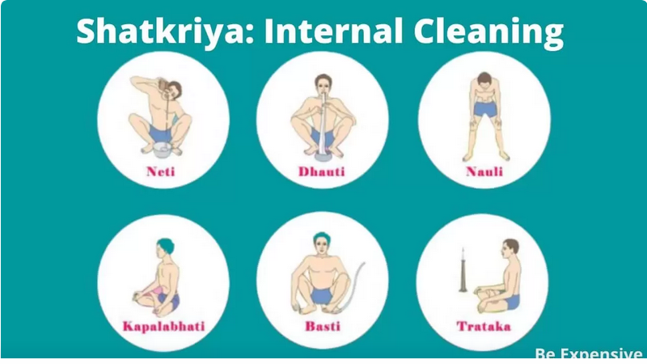

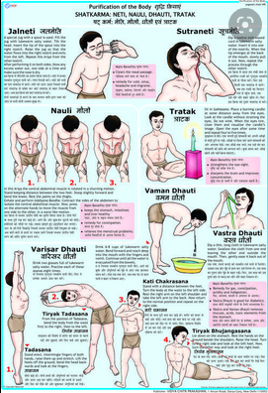
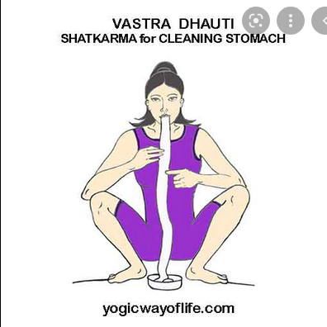

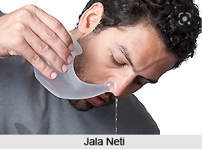
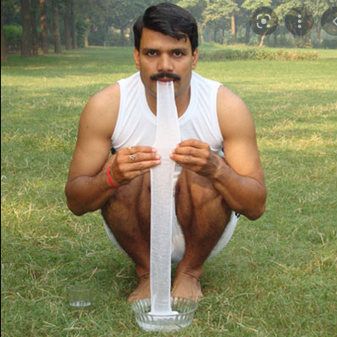
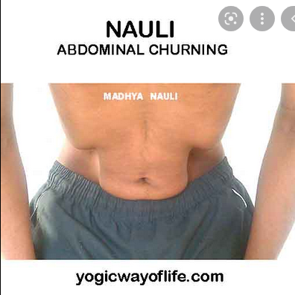

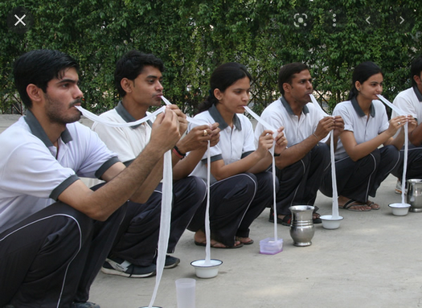


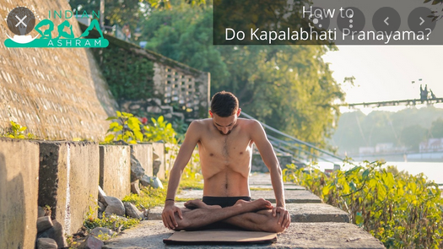

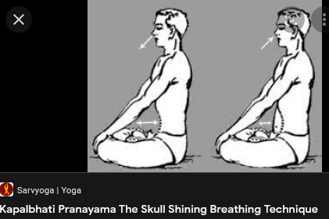
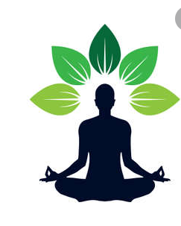
////////////////////////////////////////////////////////////////////////////////

Benefits of calisthenics
- Help you move easier throughout the day. The functional movements you perform in calisthenics can improve your mobility, reduce aches and pains, and decrease your risk for injury. ...
- Burns calories. ...
- Can improve your long-term health. ...
- It's convenient. ...
- Push-ups. ...
- Squats. ...
- Planks. ...
- Jumping exercises.

How does calisthenics affect physical fitness?
The benefits of calisthenics depend on your fitness level. For beginners who are only able to do 10-12 repetitions at a time, the workout helps build muscle strength. Once you're able to do more reps, calisthenics help increase muscle endurance -- how long you can keep up the exercise
ক্যালিসথেনিকের সুবিধাগুলি আপনার ফিটনেস স্তরের উপর নির্ভর করে। নতুনদের জন্য যারা একবারে 10-12টি পুনরাবৃত্তি করতে সক্ষম, ওয়ার্কআউটটি পেশী শক্তি তৈরি করতে সহায়তা করে। একবার আপনি আরও পুনরাবৃত্তি করতে সক্ষম হলে, ক্যালিসথেনিক্স পেশী সহনশীলতা বাড়াতে সাহায্য করে -- আপনি কতক্ষণ ব্যায়াম চালিয়ে যেতে পারেন

How does calisthenics improve your health?
Not only will you build great functional strength, making everyday tasks easier, but by reducing stress on your joints while building that strength, results in a longer lifespan for those joints. Calisthenics actually increase your resting metabolic rate, as well as enhance and develop muscular and aerobic endurance.

আপনি শুধুমাত্র দুর্দান্ত কার্যকরী শক্তি তৈরি করবেন না, দৈনন্দিন কাজগুলিকে সহজ করে তুলবেন, কিন্তু সেই শক্তি তৈরি করার সময় আপনার জয়েন্টগুলির উপর চাপ কমিয়ে সেই জয়েন্টগুলির জন্য দীর্ঘ আয়ু হবে। ক্যালিসথেনিক্স আসলে আপনার বিশ্রামের বিপাকীয় হার বাড়ায়, সেইসাথে পেশী এবং বায়বীয় সহনশীলতা বাড়ায় এবং বিকাশ করে।
Does calisthenics improve athletic performance?
Calisthenics is a resistance training that is performed in your own body way. It is specially designed to improve your flexibility, balance, strength, agility, coordination, and aerobic conditioning that leads to staying fit and being healthy. It maximizes your power and athletic ability
ক্যালিসথেনিক্স হল একটি প্রতিরোধের প্রশিক্ষণ যা আপনার নিজের শরীরের উপায়ে সঞ্চালিত হয়। এটি বিশেষভাবে আপনার নমনীয়তা, ভারসাম্য, শক্তি, তত্পরতা, সমন্বয় এবং বায়বীয় কন্ডিশনার উন্নত করার জন্য ডিজাইন করা হয়েছে যা ফিট থাকার এবং সুস্থ থাকার দিকে পরিচালিত করে। এটি আপনার শক্তি এবং অ্যাথলেটিক ক্ষমতাকে সর্বাধিক করে তোলে

What is Calisthenics and why is it so good for you?
o…what exactly is calisthenics?
Well, basically, it’s a fancy word for body weight based exercises or movements. Stuff you can do at home with minimal or no equipment. Sounds too simple to be better than going to the gym? Well actually, one of the main reasons it’s so good for you is because you don’t need a gym to get an amazing workout from it, plus it’s safer and better for your body in the long-run.
Unless you’re training for a specific sporting event, or you’re an upper-level type athlete looking to achieve specific strength related goals, then it’s safe to say that you, like the rest of us, view exercise as something that is there to maintain general levels of fitness, health and wellbeing. It’s something we have to do. After all, the human body is designed to move right?!

Maybe you’re tired of the travel time associated with getting to the gym? Maybe you’re bored of hitting the same machines over and over again? Maybe the most enjoyable part of your weekly exercise routine is the part where you’re out running on the road away from the gym?
If any of these are true for you, maybe calisthenics is something you’d benefit from.
Before we get into the justifications for why calisthenics should be part of your weekly exercise regime, let’s remind everyone about a few things to do with the human body and how we’re designed to move.
We are supposed to be able to move our own bodies. Simple. The type of requirements involved in doing a body weight related movement have always been around. Before the coming of modern society and all its amazing comforts, we lived existences which required us to move more…a lot more. We climbed more, we got onto and off the ground more, we lifted ourselves and our loved ones more in and out of things like holes, caves and trees more. Not a whole lot has changed since then in regard to our bodies. They’re pretty much exactly the same… just weaker.
Calisthenics are movements we should be fairly adapt at performing. Meaning that our bodies react well to that type of stress and we can continue that movement at a high level over a long period of time.

Here’s why that’s important when it comes to making exercise part of our weekly routine…
Being time short becomes a non-excuse
You can do a 20-minute calisthenics workout using nothing but your living room floor and be absolutely spent afterwards. This means getting to and from the gym, or not having access to equipment is no longer an excuse not to exercise. What happens if you adopt this approach? You end up exercising more over the course of a year.
Multiple muscles at once
Body weight movements, such as push ups, pull ups, jumping lunges, all work multiple muscle groups at once. For example, a pull up doesn’t just work your biceps, it also relies on your back and core muscles. You ask more of your body in a shorter amount of time, and who doesn’t like to save a bit of time these days when it comes to exercise?
More calories burnt
According to the Harvard School of Public Health, “Vigorous calisthenics burn more calories than many common cardio workouts”. This is due to the greater amount of muscle engagement that is required by these exercises as mentioned above.

Better for your body
Because you’re not lifting heavy weights, there is a reduction in risk of injury. You’re designed to be able to move yourself in different ways, meaning calisthenics is easier on your tendons, joints and muscles. You recover quicker, meaning your workload increases during the course of your exercise life and you end up getting in more workouts during the course of the year.
Not only will you build great functional strength, making everyday tasks easier, but by reducing stress on your joints while building that strength, results in a longer lifespan for those joints.
Endurance
Calisthenics actually increase your resting metabolic rate, as well as enhance and develop muscular and aerobic endurance. Not only that, but it is more effective at developing lower-body coordination compared to Pilates within the same period of time.
Money and time
Yes, callisthenic workouts can be done with ZERO equipment, but even with one or two pieces of equipment (pull up bar/dip bar) you will still save thousands on gym membership fees.
You can achieve a seriously hardcore workout as soon as you step through your own front door in just 20 minutes…that’s no travel time, no parking time, no waiting for machine time, no heading to the grocery store after the gym time…over the course of a year, this adds up tremendously.

Proprioception
Calisthenics builds your body’s proprioceptors. Proprioception is the internal sense that tells you where your body parts are without having to look at them. This internal body awareness relies on receptors in your joints, muscles, ligaments, and connective tissue. They pick up information as muscles bend and stretch as well as when your body is still.
For example, the joints, muscles, and connective tissue in your buttocks, hips, and legs are compressed (pushed together) as you sit and read this. They are “distracted” (pulled apart) when you hang from a chin-up bar. Calisthenics is one of the best ways to develop these.
We are designed to move. If we want to live the best possible life we can and feel the best we can, we have to. It’s simple.
Get in touch with usand we’ll help get you moving the way you should.

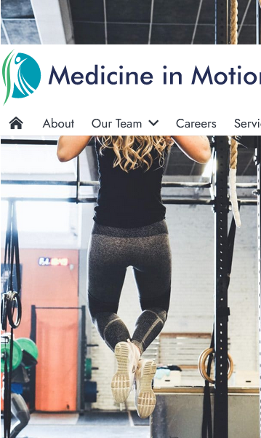

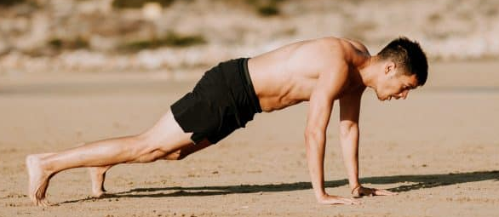
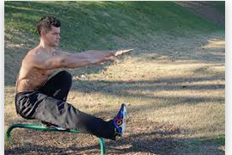

How aerobic exercise improve fitness

Aerobic Exercise
Aerobic or "with oxygen" exercises provide cardiovascular conditioning. The American Heart Association recommends a minimum of 30 minutes of cardiovascular exercise 5 to 7 days per week. Don't forget warm-up, cool-down and stretching exercises in your aerobic exercise session.
অ্যারোবিক বা "অক্সিজেন সহ" ব্যায়াম কার্ডিওভাসকুলার কন্ডিশনার প্রদান করে। আমেরিকান হার্ট অ্যাসোসিয়েশন প্রতি সপ্তাহে 5 থেকে 7 দিন ন্যূনতম 30 মিনিট কার্ডিওভাসকুলার ব্যায়াম করার পরামর্শ দেয়। আপনার অ্যারোবিক ব্যায়াম সেশনে ওয়ার্ম-আপ, কুল-ডাউন এবং স্ট্রেচিং ব্যায়াম ভুলে যাবেন না।

Benefits of aerobic exercise
- Improves cardiovascular conditioning.
- Decreases risk of heart disease.
- Lowers blood pressure.
- Increases HDL or "good" cholesterol.
- Helps to better control blood sugar.
- Assists in weight management and/or weight loss.
- Improves lung function.
- Decreases resting heart rate.
• কার্ডিওভাসকুলার কন্ডিশনার উন্নতি করে। • হৃদরোগের ঝুঁকি কমায়। • রক্তচাপ কমায়। • HDL বা "ভাল" কোলেস্টেরল বাড়ায়। • রক্তে শর্করাকে ভালোভাবে নিয়ন্ত্রণ করতে সাহায্য করে। • ওজন ব্যবস্থাপনা এবং/অথবা ওজন কমাতে সহায়তা করে। • ফুসফুসের কার্যকারিতা উন্নত করে। • বিশ্রামে থাকা হৃদস্পন্দন হ্রাস করে।

What are some examples of aerobic exercise?
Lower impact aerobic exercise includes:
- Swimming.
- Cycling.
- Using an elliptical trainer.
- Walking.
- Rowing.
- Using an upper body ergometer (a piece of equipment that provides a cardiovascular workout that targets the upper body only).
Higher impact aerobic exercise includes:

How often and for how long should I do these exercises?
The American Heart Association recommends that everyone reach a minimum of 30 minutes of some form of cardiovascular exercise 5 to 7 days per week. This can be broken up into 10-minute time periods. This means that taking 3 walks of 10 minutes each would let you reach the recommended minimum guideline for reducing the risk of heart disease, diabetes, hypertension, and high cholesterol. You would also burn the same number of calories as you would if you walked for the full 30 minutes at 1 time.
আমেরিকান হার্ট অ্যাসোসিয়েশন সুপারিশ করে যে প্রত্যেকে প্রতি সপ্তাহে 5 থেকে 7 দিন কার্ডিওভাসকুলার ব্যায়ামের জন্য ন্যূনতম 30 মিনিটে পৌঁছান। এটি 10-মিনিটের সময়ের মধ্যে বিভক্ত করা যেতে পারে। এর মানে হল প্রতিটি 10 মিনিটের 3টি হাঁটা আপনাকে হৃদরোগ, ডায়াবেটিস, উচ্চ রক্তচাপ এবং উচ্চ কোলেস্টেরলের ঝুঁকি হ্রাস করার জন্য প্রস্তাবিত ন্যূনতম নির্দেশিকাতে পৌঁছাতে দেবে। আপনি যদি 1 সময়ে পুরো 30 মিনিট হাঁটেন তবে আপনি একই সংখ্যক ক্যালোরি পোড়াবেন।
Explanation of intensity
The intensity is determined by how hard you are working. The intensity of the exercise is determined by what your goals are, what limitations you have, and your current fitness level.
Heart rate and exercise
Your heart rate increases in direct correlation with the intensity of the exercise. Heart rate levels can vary significantly from one person to another based on fitness level, genetics, environment, and exercise tolerance. If you wish to train based on heart rate, contact your health care provider to determine what the appropriate range is for you. Some medications, most often blood pressure drugs, control heart rate, making it impossible to determine exercise intensity in this way. Ask your physician to determine if you are on any of these medications.
আপনার হৃদস্পন্দন ব্যায়ামের তীব্রতার সাথে সরাসরি সম্পর্ক বাড়ায়। ফিটনেস লেভেল, জেনেটিক্স, পরিবেশ এবং ব্যায়াম সহনশীলতার উপর ভিত্তি করে হার্টের হারের মাত্রা একজন থেকে অন্য ব্যক্তির মধ্যে উল্লেখযোগ্যভাবে পরিবর্তিত হতে পারে। আপনি যদি হার্টের হারের উপর ভিত্তি করে প্রশিক্ষণ নিতে চান, তাহলে আপনার জন্য উপযুক্ত পরিসর কী তা নির্ধারণ করতে আপনার স্বাস্থ্যসেবা প্রদানকারীর সাথে যোগাযোগ করুন। কিছু ওষুধ, প্রায়শই রক্তচাপের ওষুধ, হৃদস্পন্দন নিয়ন্ত্রণ করে, এইভাবে ব্যায়ামের তীব্রতা নির্ধারণ করা অসম্ভব করে তোলে। আপনি এই ওষুধগুলির মধ্যে কোনটি ব্যবহার করছেন কিনা তা নির্ধারণ করতে আপনার চিকিত্সককে জিজ্ঞাসা করুন।

Monitoring intensity in other ways
How can you know if you are working at the right intensity? Using an RPE (Rate of Perceived Exertion) chart can help you to determine the appropriate intensity. The scale uses a 1 to 10 rating system. One is very light, such as walking to the refrigerator for a glass of milk. Ten would be a very significant level, representing maximal exercise. Ten would be indicative of not being able to take another step without fear of collapse. It is not recommended for anyone to work at a rate of 10 without strict supervision by a healthcare provider. Moderate intensity is the level of exercise that is most recommended, and can be determined by a rating between a 3 and a 5.
Warming up and cooling down
Every session of aerobic exercise should include a warm-up and cool-down. The warm-up period should not include static stretching, but should instead be a gradual increase in pace and intensity of the exercise. This allows the body to increase blood flow to the muscles and decreases the likelihood of a muscle or joint injury. The warm-up should last between 5 and 10 minutes. The cool-down session should last a similar amount of time as the warm-up, with the pace gradually decreasing. Stretching exercises would be appropriate after aerobic exercise.
অ্যারোবিক ব্যায়ামের প্রতিটি সেশনে ওয়ার্ম-আপ এবং কুল-ডাউন অন্তর্ভুক্ত করা উচিত। ওয়ার্ম-আপ পিরিয়ডে স্ট্যাটিক স্ট্রেচিং অন্তর্ভুক্ত করা উচিত নয়, বরং ব্যায়ামের গতি এবং তীব্রতা ধীরে ধীরে বৃদ্ধি করা উচিত। এটি শরীরের পেশীতে রক্ত ​​প্রবাহ বাড়াতে দেয় এবং পেশী বা জয়েন্টে আঘাতের সম্ভাবনা হ্রাস করে। ওয়ার্ম-আপটি 5 থেকে 10 মিনিটের মধ্যে স্থায়ী হওয়া উচিত। কুল-ডাউন সেশনটি ওয়ার্ম-আপের মতো একই পরিমাণ সময় স্থায়ী হওয়া উচিত, গতি ধীরে ধীরে কমতে থাকে। অ্যারোবিক ব্যায়ামের পরে স্ট্রেচিং ব্যায়াম উপযুক্ত হবে।

Progression of aerobic exercise
Progression to higher intensities of exercise should be based on individual exercise tolerance. There are 3 methods for challenging aerobic fitness:
- Increase speed.
- Increase the resistance.
- Increase the duration.
Any of these methods, or a combination of these methods, will improve aerobic fitness. Increasing intensity should be done very gradually. You should challenge yourself for only a few minutes at a time.
